**TEAM PROJECT I**

**TEAM NAMES AND SURNAMES;**

**Sevval Simsek**

**Oluwadamilola Adeniyi**

**Dennis Ifemidayo Opoola**

**Emmanuel Aliohi Joseph**

**Nicat Agayev**

**FAMILY TREE**

**Introduction**

A family tree is a chart that represents family relationships in a tree structure. A genogram is a pictorial display of a person’s family relationships and medical history. The difference between a genogram and a family tree is that a genogram allows the user to visualize hereditary patterns and psychological factors that punctuate relationships.

**What Has Been done in the Project**

The family tree data structure is implemented using all functionalities in main program.

In my family tree user can:

* Add new person
* Find relationship between two persons
* Search
* Destroy
* Display (beta)

Using family tree data type one can create any number of family trees and merge them also!

**Image Reference**

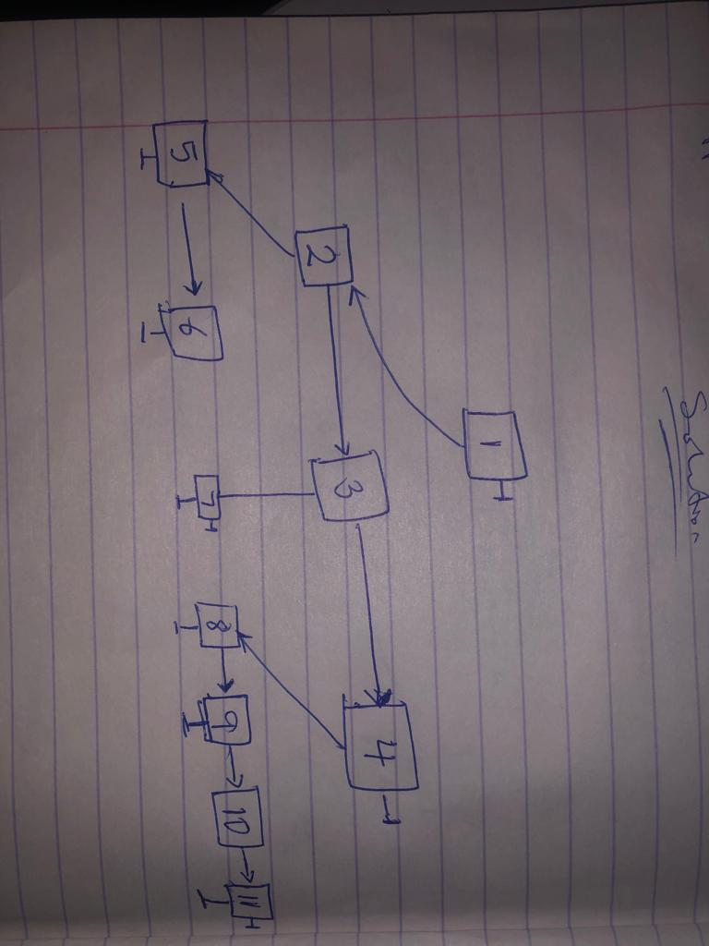

**THE END**

**General Characteristics of the Project**

The family structure is the first element of the family systems theory. It includes the dimensions that make every family unique such as:

* family size
* family form

**Why Such a Topic?**

A family tree is a representation of the lineages of a particular family mainly consisting of relatives stretching as far as possibly establishable by the family. A simple family tree would basically constitute of great grand parents, grand parents, parents, siblings, cousins and so on.

**The Purpose of the Project**

The overall purpose of Family Tree is to help you discover your family and, in turn, discover a bit about yourself. Family Tree is different from other similar genealogy sites in that it is a single, public tree linked together in families, rather than a site that only allows users to create and manage their own private trees

**Conclusion**

In this document, we have explained the functions and structure of a Family tree.